Day 0 = 27/04/2026
Installing the softwares.
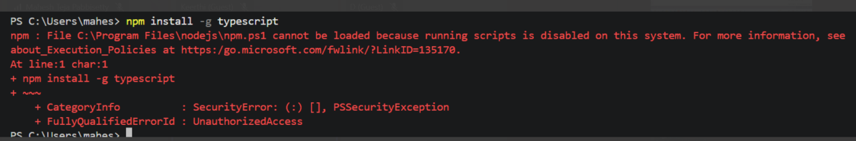
While installing typescript or anything in vs code we needs to run the below command.
set-ExecutionPolicy -Scope CurrentUser -ExecutionPolicy RemoteSigned

npm install -g typescript
npm install -g tsx
-g is nothing but to install the typescript or tsx globally.

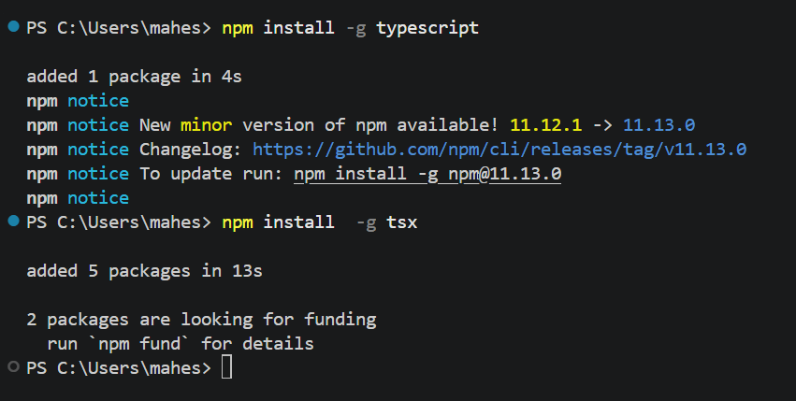

Day 1 - 28/04/2026
https://edunexgenqa-my.sharepoint.com/personal/proy_edunexgenqa_onmicrosoft_com/_layouts/15/stream.aspx?id=%2Fpersonal%2Fproy%5Fedunexgenqa%5Fonmicrosoft%5Fcom%2FDocuments%2FRecordings%2FPlaywright%20Typescript%20May%202026%2D20260428%5F213820%2DMeeting%20Recording%2Emp4&nav=eyJyZWZlcnJhbEluZm8iOnsicmVmZXJyYWxBcHAiOiJTdHJlYW1XZWJBcHAiLCJyZWZlcnJhbFZpZXciOiJTaGFyZURpYWxvZy1MaW5rIiwicmVmZXJyYWxBcHBQbGF0Zm9ybSI6IldlYiIsInJlZmVycmFsTW9kZSI6InZpZXcifX0&ga=1&referrer=StreamWebApp%2EWeb&referrerScenario=AddressBarCopied%2Eview%2E86fc24ea%2D323d%2D4881%2D8b41%2D3f43c50916c2
Static languages (e.g., C++, Java, Rust) check variable types and perform optimizations during compilation, leading to faster, safer, early error detection.Run-time (dynamic) languages (e.g., Python, JavaScript) determine types while the program executes, offering higher flexibility

//variable - storage/container - which stores either a single vlaue or multiple values
// There are 3 ways in which we can declare the variabl (JS & TS)
// syntax to declare a variable - (keyword(var/let/const) variablename = vale - JS
// syntax to declare a variable - (keyword(var/let/const) variablename :datatype(optional) = vale - TS
//let i = 10
//let j:number = 36

//var = in modern JS & TS we do not use var keyword >version 5 - ES 6 (ECMA SCRIPT 6 - 2015)
//let = if the value of any variable can change at any point of time
//const = To declare a constant variable (if the value of any variable cannot change at any point of time)
// scope of variable: 2 type of scope
// 1.Local scoped variables - when we declare a variable inside of curlybrasis {...} below is the example
/*
{
let lang= "js"//local scoped variable
console.log(lang);
}
console.log(lang);
*/
// 2.Global scoped variables - when we declare a variable outside of curlybrasis {...} below is example
let lang1="TS" // Global scoped variable
{
let lang ="JS" // Local scoped variable
console.log(lang1)
console.log(lang)
}
console.log(lang1)

// var -

// 1.scope - functional or global in nature
// 2. whenever you declare a varaible using var keyboard it can be redeclared and can also re-initialised
// 3. Hoisting: we can access the variable before its declaration as well.
// 4. It is not mandatory to assign the variable at the time of declaration

//Example for point4
var num10
num10 = 11111111

//Example for point3
console.log(num1);

//Example for point2
var num1=10
num1 = 89 // reinitialisation
var num1 = 90
var num1 = 100 // redeclared
console.log(num1);

//Example for point1
var name1 = "java"
{
var name1="python"
}
console.log(name1)

var name2 ="java"
function name3(){
var name2 = "python"
}
console.log(name2);

Day 2 - 29/04/2026
//var
// 1. scope - functional or global
// 2. Whenever you declare a variable using "var" keyword it
// can be redeclared and can also re-initialised.
// 3. Hoisting: We can access the variable before it's declaration as well.
// 4. It is not mandatory to assign the variabe at the time of declaration

// let

// 1. Scope - Block level { ... } scope or global scope
// 2. Whenever you declare a variable using "let" keyword it
// cannot be redeclared but can be re-initialised.
// 3. Hoisting: We cannot access the variable before it's declaration.
// 4. It is not mandatory to assign the variabe at the time of declaration

// const
I
// 1. Scope - Block level { ... } or global
// 2. Whenever you declare a variable using "const" keyword it
// cannot be redeclared and cannot be re-initialised.
// 3. Hoisting: We cannot access the variable before it's declaration.
// 4. It is mandatory to assign the variabe at the time of declaration

